# SRI RAMAKRISHNA ENGINEERING COLLEGE

[Educational Service: SNR Sons Charitable Trust] [Autonomous Institution, Reaccredited by NAAC with ‘A+’ Grade]

[Approved by AICTE and Permanently Affiliated to Anna University, Chennai] [ISO 9001:2015 Certified and all eligible programmes Accredited by NBA] Vattamalaipalayam, N.G.G.O. Colony Post, Coimbatore – 641 022.

# DEPARTMENT OF ELECTRONICS AND COMMUNICATION

**ENGINEERING CAPSTONE PROJECT REPORT**

# APPLICATION OF PID CONTROLLER IN DC MOTOR SPEED CONTROLLING

SANGAMESH G (2002206)

SANJEEV S.R (2002211)

SRI KARTHICKRAJA V (2002227)

# THIRD YEAR B.E. ECE – V SEM

**Academic Year 2022-2023**

# 20EI278 & CONTROL SYSTEM LABORATORY

**FACULTY IN-CHARGE Dr.S.PADMAPRIYA, AP/ECE**

# SRI RAMAKRISHNA ENGINEERING COLLEGE

[Educational Service: SNR Sons Charitable Trust] [Autonomous Institution, Reaccredited by NAAC with ‘A+’ Grade]

[Approved by AICTE and Permanently Affiliated to Anna University, Chennai] [ISO 9001:2015 Certified and all eligible programmes Accredited by NBA]

Vattamalaipalayam, N.G.G.O. Colony Post, Coimbatore – 641 022.

# DEPARTMENT OF ELECTRONICS AND COMMUNICATION

**ENGINEERING**

# CAPSTONE PROJECT REPORT 20EI278 & CONTROL SYSTEM LABORATORY

# APPLICATION OF PID CONTROLLER IN DC MOTOR SPEED CONTROLLING

# Assessment

|  |  |  |  |  |  |  |
| --- | --- | --- | --- | --- | --- | --- |
| **Sl.**  **No.** | **Name & Roll No.** | **Description (2)** | **Implementation (3)** | **Result (3)** | **Report (2)** | **Total (10)** |
| **1.** | **SANGAMESH G (2002206)** |  |  |  |  |  |
| **2.** | **SANJEEV S.R (2002211)** |  |  |  |  |  |
| **3.** | **SRI KARTHICKRAJA V (2002227)** |  |  |  |  |  |

**SIGNATURE OF FACULTY IN-CHARGE Dr.S.PADMAPRIYA, AP/ECE**

# CONTENTS

|  |  |  |
| --- | --- | --- |
| **S. No.** | **TITLE** | **PAGE NUMBER** |
| APPLICATION OF PID CONTROLLER IN DC MOTOR SPEED CONTROLLING | | |
| 1. | ABSTRACT |  |
| 2. | INTRODUCTION |  |
| 3. | IMPLEMENTATION |  |
| 4. | SIMULATION |  |
| 5. | OUTPUT |  |
| 6. | RESULT |  |

**DC MOTOR SPEED CONTROL WITH LAG COMPENSATOR AND PID**

# ABSTRACT:

The purpose is to control the angular rate of the load (shaft position) of a DC motor by varying the applied input voltage. A linear differential equation describing the electromechanical properties of a DCmotor to model (transfer function) the relation between input and output was first derived using basic laws of physic. This transfer function was used to analyze the performance of the system and to design proper controllers (Lag compensator and PID) to meet the design criteria. The locations of the desired poles were found from the design criteria (settling time, percent overshoot).

A common actuator in control systems is the DC motor. It directly provides rotary motion and coupled with wheels or drums and cables can provide transitional motion. The electric circuit of the armature and the free body diagram of the rotor.

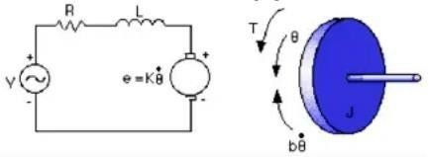

# INTRODUCTION:

Using root locus, it was found that a lag compensator is required to meet this design criterion and place poles in the desired locations. A second lag compensator was also designed to meet the steady-state requirements of the problem. The result of the final lag compensator on the closed-loop response is achieved. A settling time of 0.844 seconds, a percent overshoot of 1.91%, and a steady-state error of 0.1%were achieved using the designed lag compensator. PID controller was also used in this problem to meet the design criteria. Using a trial and error approach, PID gains were first tuned and implemented. A settling time of 0.8seconds without any percent overshoot and zero steady-state error were achieved with the PID controller. Details of the design procedure and Matlab code.

# IMPLEMENTATION:

There are different types of controllers like lead, lag, LQR (linear quadratic regulator), PID, and sliding-mode control that could be incorporated into control applications. Among the few mentioned types of controllers, the PID controller is one of the earliest and best-understood controllers which is incorporated in almost every industrial control application due to its efficiency and ease of implementation. Although there are many classical techniques for designing and tuning PID controller parameters that are widely understood and easily applied, one of the main disadvantages of these classical techniques is that, for tuning PID controllers through these techniques, expertise and experience are required. This is so because these methods provide a starting point and achieving desired performance fine-tuning of parameters through the hit-and-trial method is required. However, metaheuristic techniques may be a good choice to their dynamic nature.

# SIMULATION:

clc; clear all; close all; J=0.02; b=0.2; kt=0.02; ke=0.02; R=2; L=0.4;

num=[kt];

den=[J*L J*R+b*L b*R+ke*kt ];

disp('Open loop Transfer function without controller') TF_DC=tf(num,den) [numclp,denclp]=cloop(num,den,-1);

disp('Closed loop Transfer Function without controller') tf(numclp,denclp)

step(num,den,0:0.1:5),grid on

title('Open loop response without controller') figure

step(numclp,denclp,0:0.1:5),grid on title('Closed loop response without controller') A=[-(R/L) -(ke/L);(kt/J) -(b/J)];

B=[1/L; 0];

C=[0 1]; D=0;

disp('State Space representation:') SYS_DC=ss(A,B,C,D)

if det(ctrb(A,B))==0

disp(' ----------> System is NOT Controllable < ')

else

disp(' ----------> System is Controllable < ')

end

if det(obsv(A,C))==0

disp(' ----------> System is NOT Observable < ')

else

disp(' ----------> System is Observable < ')

end figure

rlocus(num,den),grid on

title('Root Locus without controller') Ts=1;

SSE=0.4;

abs(roots([1+(((-log(PO))/pi)^2) 0 -(((-log(PO))/pi)^2)])); % Damping ratio Damp=ans(1);

Wn=4/(Ts*Damp);

disp('Desired Damping ratio is:'),Damp disp('Desired Natural Frequency is:'),Wn dend=[1 2*Wn*Damp Wn^2];

disp('Desired Characteristic Equation is:'),dend Dp=roots(dend);

disp('Desired Pole locations:'),Dp z1=14;

den=den/den(1);

ANS=inv([den(1) -dend(1) 0;den(2) -dend(2) num(1);den(3) -dend(3) num(1)*z1])*[dend(2)- den(2);dend(3)-den(3);0];

disp('Pole of the first lag compensator is:') p1=ANS(1)

c=ANS(2);

disp('Gain of the first lag compensator is:') K=ANS(3)

numlag1=K*[1 z1]; denlag1=[1 p1];

disp('Transfer function of the first Lag compensator to improve Ts and PO%:') tf(numlag1,denlag1)

disp('DC motor Transfer function with Lag compensator') NUM=conv(numlag1,num);

DEN=conv(denlag1,den); TF=tf(NUM,DEN)

figure rlocus(TF),grid on

title('Root locus with Lag compensator 1') figure

step(TF,0:0.1:5),grid on

title('Open loop response with lag compensator 1') [numc,denc]=cloop(NUM,DEN);

figure step(numc,denc,0:0.1:5),grid on

title('Closed loop response with Lag compensator 1 that improves Ts & PO%') z2=2.9;

SSE=0.004

disp('pole of the 2nd lag compensator') p2=(1+((K*z1*num(1)/denlag1(2))/den(3)))*z2*SSE numlag2=[1 z2];

denlag2=[1 p2]; NumLag=conv(numlag1,numlag2); DenLag=conv(denlag1,denlag2);

disp('The 2nd Lag compensator Transfer function to improve SSE:') tf(numlag2,denlag2)

disp('The overal Lag compensator transfer function (lag1*lag2):') tf(NumLag,DenLag)

NumDC=conv(NumLag,num); DenDC=conv(DenLag,den);

disp('Open loop TF of the DC motor with final Lag compensator (improved Ts, PO% & SSE) ') tf(NumDC,DenDC)

figure

rlocus(NumDC,DenDC), grid on

title('Root locus with final lag compensator') [NumCLP,DenCLP]=cloop(NumDC,DenDC);

disp('closed loop TF of the DC motor with final Lag compensator (improved Ts, PO% & SSE) ') tf(NumCLP,DenCLP)

figure

step(NumCLP,DenCLP,0:0.1:5), grid on

title('Closed loop response with final Lag compensator') kp=70;

ki=170;

kd=5;

numPID=[kd kp ki]; denPID=[1 0];

num_DC_PID=conv(num,numPID); den_DC_PID=conv(den,denPID);

disp('Open loop TF of DC motor with PID controller') tf(num_DC_PID,den_DC_PID) [NumPID_CLP,DenPID_CLP]=cloop(num_DC_PID,den_DC_PID); disp('Closed loop TF of DC motor with PID controller') tf(NumPID_CLP,DenPID_CLP)

figure

step(NumPID_CLP,DenPID_CLP), grid on title('Closed loop response of DC with PID Control') figure

margin(numclp,denclp), grid on figure

margin(numc,denc), grid on figure

margin(NumPID_CLP,DenPID_CLP), grid on

**OUTPUT:**

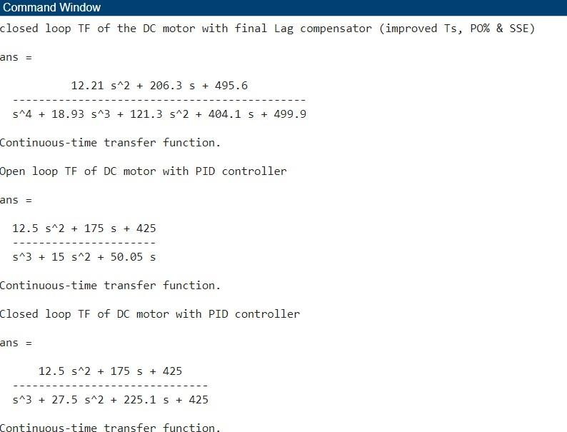

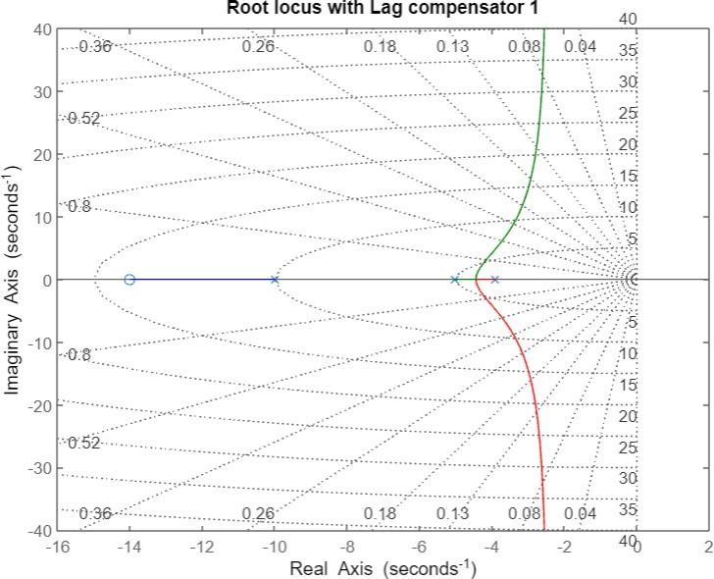

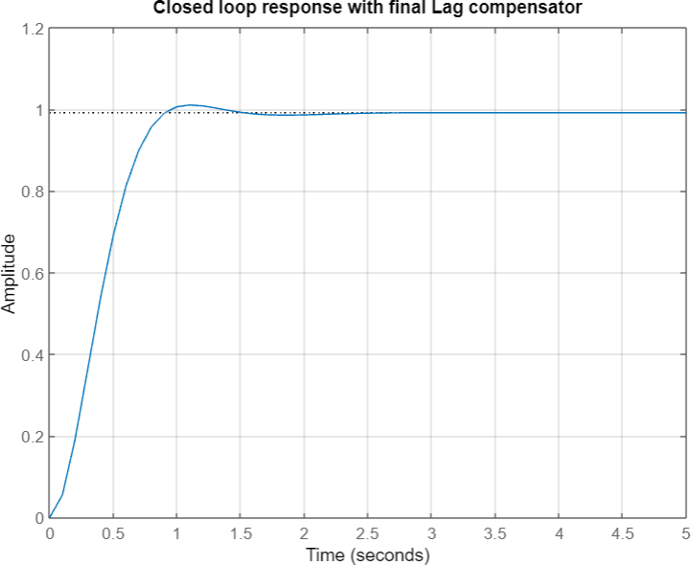

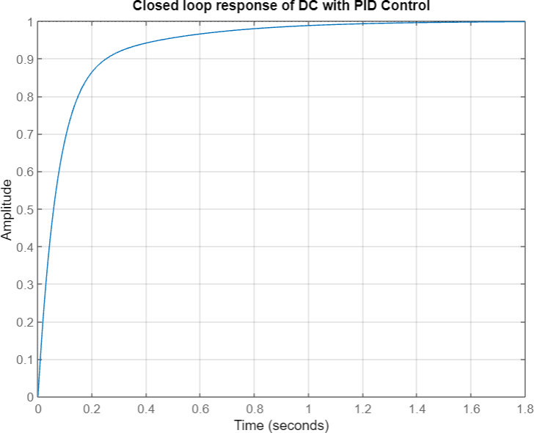

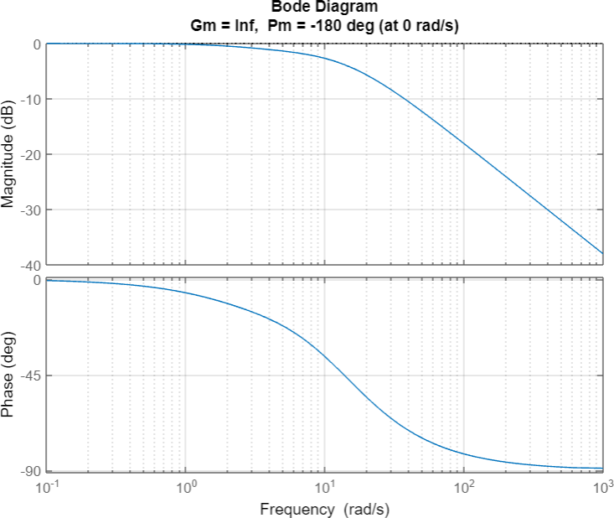

# RESULT:

Thus DC Motor speed control with lag compensator and PID controller using MatLab was verified successfully.